Promt:
Generate Python code for a simple calculator app
Genera un poema sobre el bien y el mal

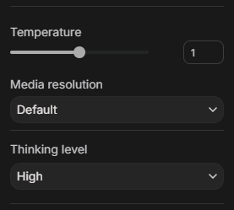
T1-D-H
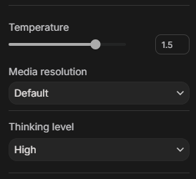
T1.5-D-H
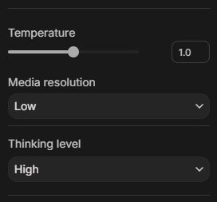
T1-L-H
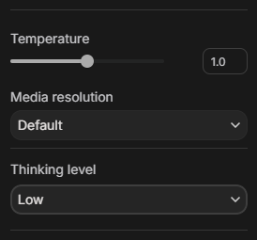
T1-D-L

